// program to find the reverse of a number

class ReverseNum

{

public static void main(String args[])

{

int num =123;

int rev=0, rem=0;

System.out.println("The Number to be reversed is "+num);

while(num!=0)

{

rem = num%10;

rev = rev*10+rem;

num = num/10;

}

System.out.println("Reversed Number = "+rev);

}

}

**OUTPUT:**

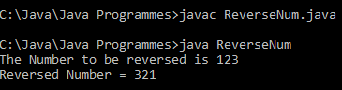

// Program to find the fibanocci series

class Fibanocci

{

public static void main(String args[])

{

int firstNum =0;

int secondNum =1;

int nextNum;

int limit = 10;

System.out.println("Fibanocci Series for "+limit+" terms = ");

for(int i=1;i<=limit;i++)

{

System.out.print(firstNum+" , ");

nextNum = firstNum+secondNum;

firstNum = secondNum;

secondNum = nextNum;

}

}

}

**OUTPUT:**

